This is to certify that
(INSERT NAME HERE)
attended an online session of
BVA Carpool Cases:
Farm vet career pathways
Presented by
Ian Cure
& hosted by James Russell
on
19th January 2021
This equates to 1 hour of EMS*

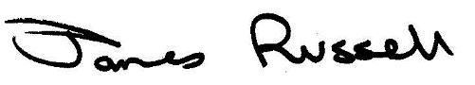

If your university requires it, this certificate is valid if screenshots are inserted into the boxes below. Note, please ensure any relevant information, such as the time, is visible.
SCREENSHOT TO SHOW BEGINNING OF SESSION
Paste a screenshot of the beginning of the session, or recording, here

SCREENSHOT TO SHOW END OF SESSION
Paste a screenshot of the end of the session, or recording, here

