This is to certify that
(INSERT NAME HERE)
attended an online session of
BVA Carpool Cases:
Is Farm Animal Welfare being overlooked in favour of production?
Presented by
Matt Dobbs
& hosted by James Russell
on
26th January 2021
This equates to 1 hour of EMS*

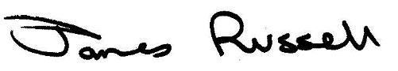

If your university requires it, this certificate is valid if screenshots are inserted into the boxes below. Note, please ensure any relevant information, such as the time, is visible.
SCREENSHOT TO SHOW BEGINNING OF SESSION
Paste a screenshot of the beginning of the session, or recording, here

SCREENSHOT TO SHOW END OF SESSION
Paste a screenshot of the end of the session, or recording, here

